

CSUC201 Fundamentals of Data Structures and Algorithms 25DCE118

FACULTY OF TECHNOLOGY AND ENGINEERING

DEVANG PATEL INSTITUTE OF ADVANCE TECHNOLOGY

AND RESEARCH

DEPARTMENT OF COMPUTER ENGINEERING

A.Y 2026 – 27 Semester – 3

LAB MANUAL

CSUC201 Fundamentals of Data Structures and Algorithms

DEPSTAR 1
CSUC201 Fundamentals of Data Structures and Algorithms 25DCE118

Practical 2 — Linear and Binary Search: Iterative and Recursive Approaches

Problem 1 — License Plate Search

Question:

A security guard at a parking lot checks vehicles one by one from the entrance to find a car with a specific license plate. Sometimes he starts from the entrance, sometimes he calls a helper who starts from where the guard left off. Given a list of license plates and a target plate, implement both approaches — one that checks plates one by one from the start, and one where the function calls itself to continue checking — and report the position of the target plate if found.

Describe the approach you used. What happens in your solution if the target plate appears more than once in the list? Does it find the first occurrence, the last, or just any one?

For Code :

https://github.com/kvvaghasiya49/FDSA/tree/6fb2f463bf1f58ac 408ada5ca8ffdaa64bc82087/DSA

DEPSTAR 2
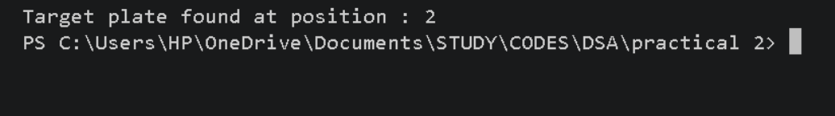
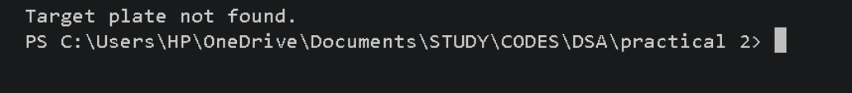
CSUC201 Fundamentals of Data Structures and Algorithms 25DCE118

Output :

Code (Iterative):

Code (Recursive):

Challenges Faced:

I wrote both an iterative and a recursive version of linear search. The iterative one was simple — a loop that checks each plate and stops when it finds a match. The recursive version was trickier: I hadtomakethefunctioncallitselfwithi+1tocheckthenextplate. Initially, my recursive version had a bug — when a plate didn't match, the function didn't return anything in that case, which caused undefined behaviour. I fixed it by adding an else branch so it properly calls itself again when there's no match.

DEPSTAR 3
CSUC201 Fundamentals of Data Structures and Algorithms 25DCE118

Learning Outcomes:

1. I learned that recursion can do the same job as a loop, where each call handles one step and moves forward by calling itself again.

2. I understood that every path in a recursive function must return something, otherwise it leads to bugs like the one I faced.

3. I learned that recursion uses extra memory (stack space) for eachcall,whilealoopdoesn't,eventhoughbothtakethesame O(n) time.

4. This helped me understand the trade-off between recursion (easier to write sometimes) and iteration (more memory efficient).

DEPSTAR 4

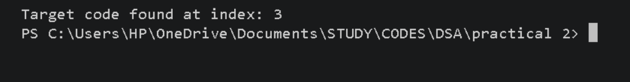
CSUC201 Fundamentals of Data Structures and Algorithms 25DCE118

Problem 2 — Library Catalog Search

Question:

A librarian maintains a sorted catalog of book codes and needs to locate a specific code quickly. Instead of going through every book, she opens thecatalogtothemiddle,checkswhetherthetargetistotheleftorright, and repeats. Given a sorted list of book codes and a target code, implement both approaches — one using a loop and one where the function calls itself — and report the position of the target code.

Describe the approach you used. What is the one condition your input must satisfy for this approach to work correctly? What would go wrong if that condition was not met?

For Code :

https://github.com/kvvaghasiya49/FDSA/tree/6fb2f463bf1f58ac40 8ada5ca8ffdaa64bc82087/DSA

Output :

Code (Iterative):

Code (Recursive):

DEPSTAR 5
CSUC201 Fundamentals of Data Structures and Algorithms 25DCE118

Challenges Faced:

I implemented both iterative and recursive versions of binary search, where the middle element is checked each time and the half that can't contain the target is discarded. The recursive version worked correctly, but my iterative version had two bugs — the mid value was calculated wrong (it ignored low), and high was set to the array size instead of the last valid index. This caused wrong results. I fixed it by correcting the mid formula to low + (high - low) / 2 and setting high = n - 1 properly.

Learning Outcomes:

1. I learned that small mistakes in calculating mid or setting the initial range can break the whole search, even if the overall logic is correct.

2. I understood that binary search only works if the array is sorted, otherwise it can give wrong results without any error.

3. I learned that both iterative and recursive versions take O(log n) time, since the search area is cut in half every step.

4. This helped me realize the importance of testing edge cases (like initial values of low and high) instead of assuming the logic is correct just because it looks right.

DEPSTAR 6
CSUC201 Fundamentals of Data Structures and Algorithms 25DCE118

Key Questions / Analysis / Interpretation to be Evaluated During/After

Implementation

1. [Problem 1] If the target plate appears near the end of a very long list, your solution still checks every plate before it. Can you think of any property the input would need to have for you to skip checking some plates entirely? What does Problem 2.2 tell you about this?

Ans :

To skip checking every plate, the list would need to be sorted. If it's sorted, we can use binary search (like in Problem 2.2) instead of checking one by one — this lets us skip large portions of the list by comparingwiththemiddleelement,insteadofcheckingeveryplate from the start.

2. [Problem 2] What is the consequence of applying your solution to a list that is not sorted? Would it always give a wrong answer, or only sometimes? Explain your reasoning without running any example..

Ans :

It would only give the wrong answer sometimes, not always. Since binary search decides which half to discard based on comparing the middle element with the target, this only works correctly if the array is sorted. On an unsorted array, the target might sometimes still be found by luck (if it happens to lie in the half that gets checked), but other times it would be wrongly skipped and the search would say "not found" even if the target is actually present.

DEPSTAR 7
CSUC201 Fundamentals of Data Structures and Algorithms 25DCE118

Faculty Remarks:

DEPSTAR 8

